Splunk ITSI includes an 'APM Module' with pre-defined Key Performance Indicators (KPIs) for application performance. Adding APM KPIs to an ITSI Service is as simple as adding the New Relic TA, ingesting the data and selecting which KPIs you wish to include in your service. Here's the configuration:

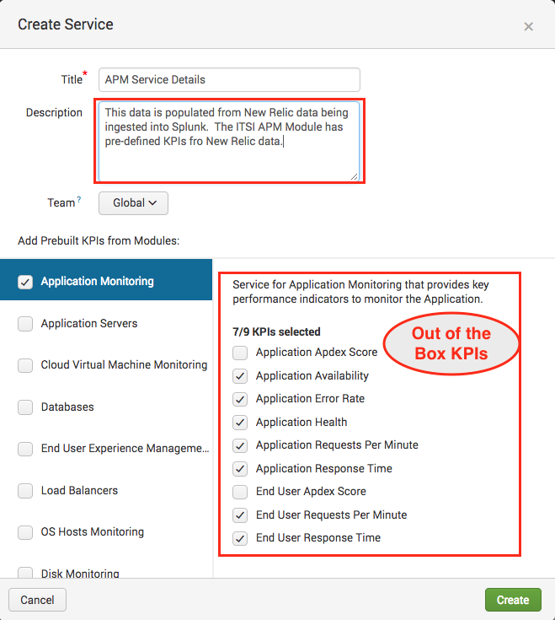

Once the KPIs are added to your service, you can use static thresholds or apply ITSI's machine learning via Adaptive Thresholding to enable alerting. In the screenshot below we created a Service with a KPI for Website Requests. Using ITSI's Adaptive Thresholding we are able to apply machine learning to "learn" what the thresholds should be using standard deviation across weekdays and weekends all with the click of a button.

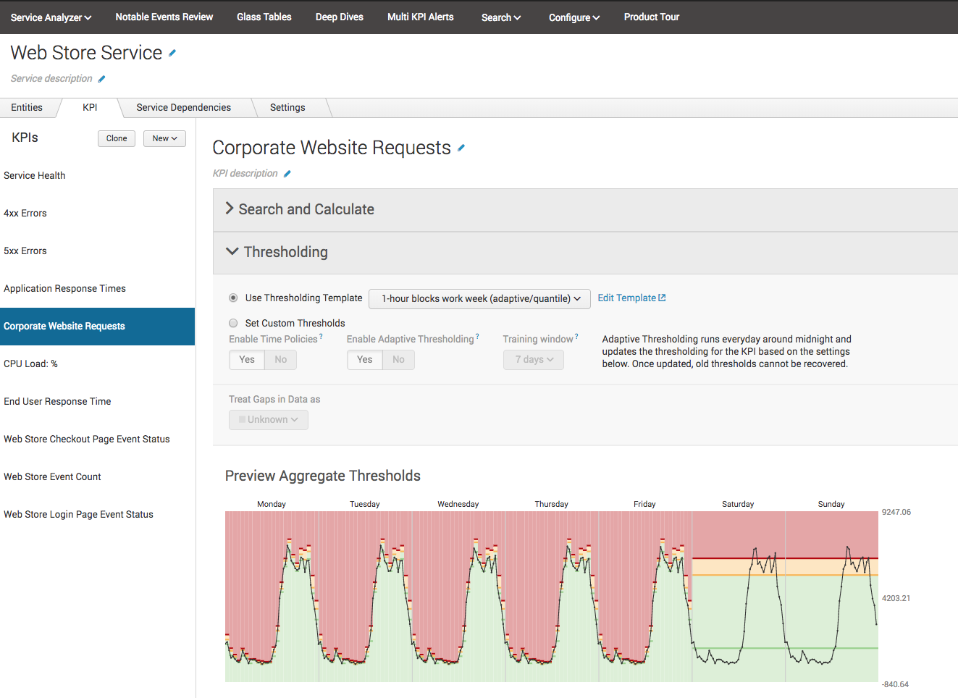

With your KPIs added and thresholds set, you can create Glass Tables with any KPIs from any of your Services by simply dragging and dropping them onto a blank canvas:

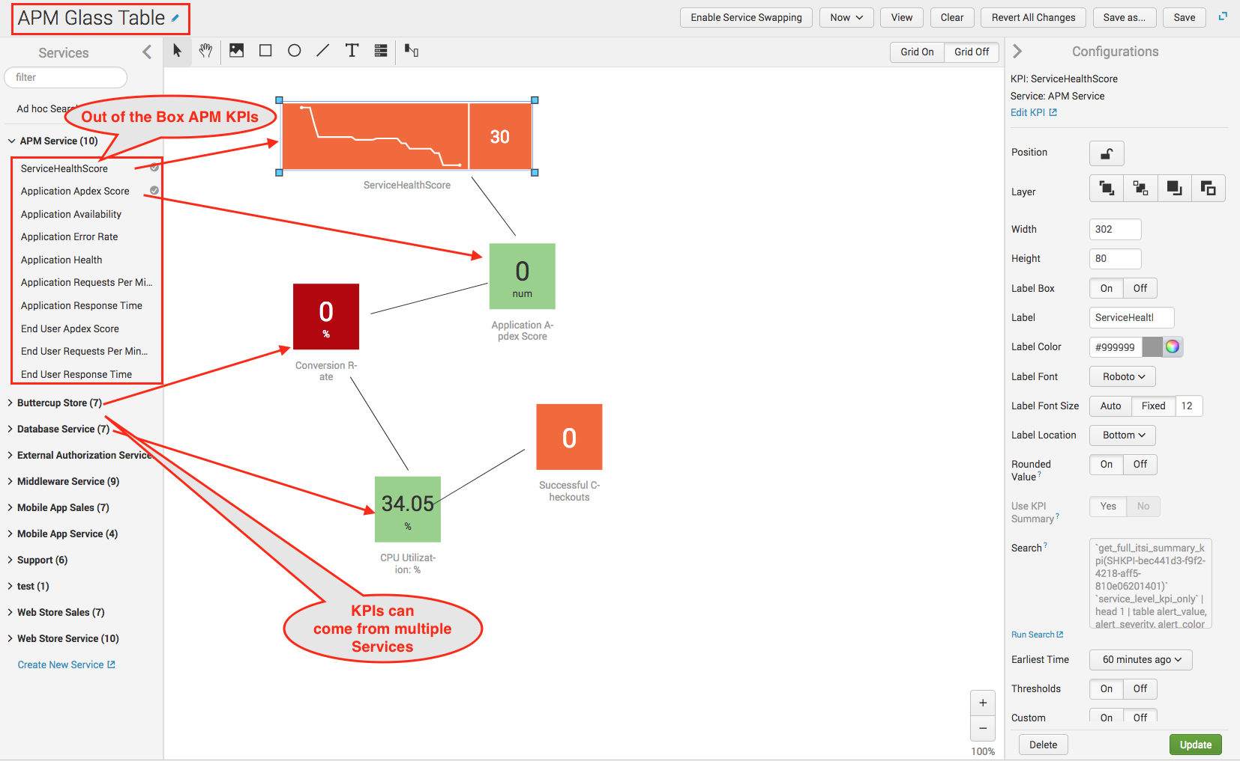

Glass Tables are extremely flexible and can contain just about anything you want. From background images to the merging of operational and business metrics on a single dashboard. Here's an example of a bit more polished Glass Table:

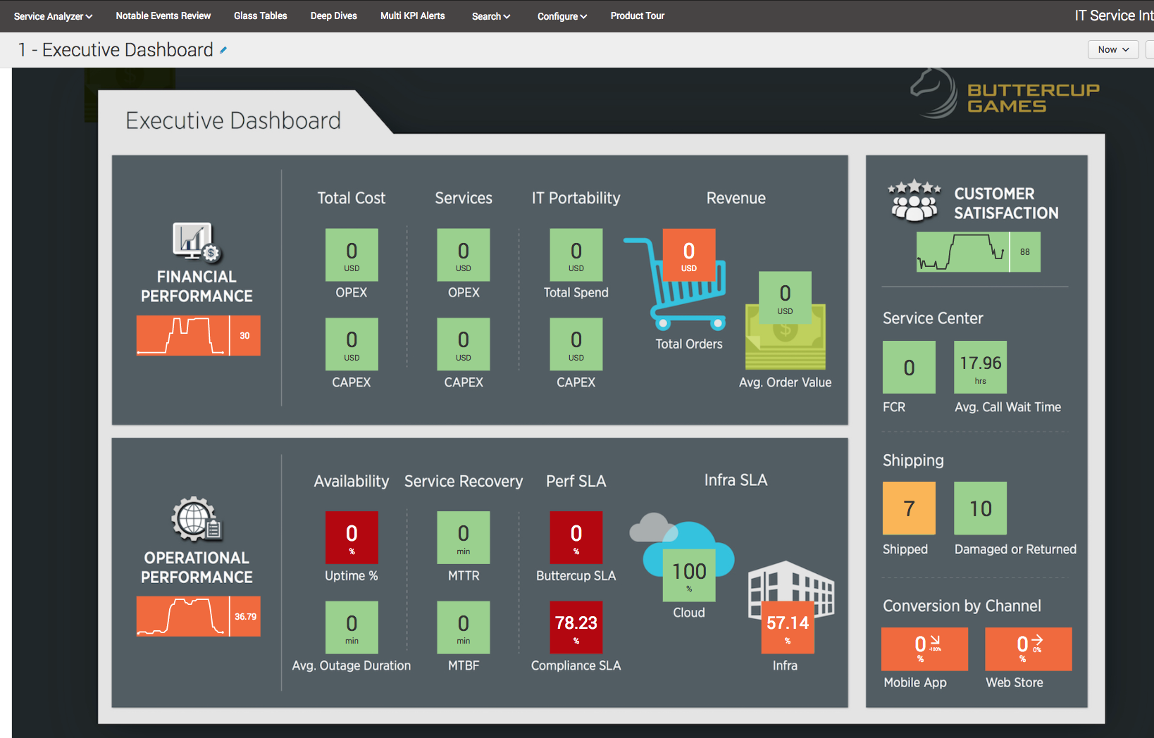

Glass Tables can include links from the various KPIs to other Glass Tables, other Splunk Dashboards, external websites or ITSI Deep Dives. Here's an example of an ITSI Deep Dive showing KPIs from multiple Services. As you can see it's easy to visually correlate to see the how various KPIs react in relation to each other. It his specific case, the Storage Server ran out of free disk space which ultimately lead to database errors and application performance issues.

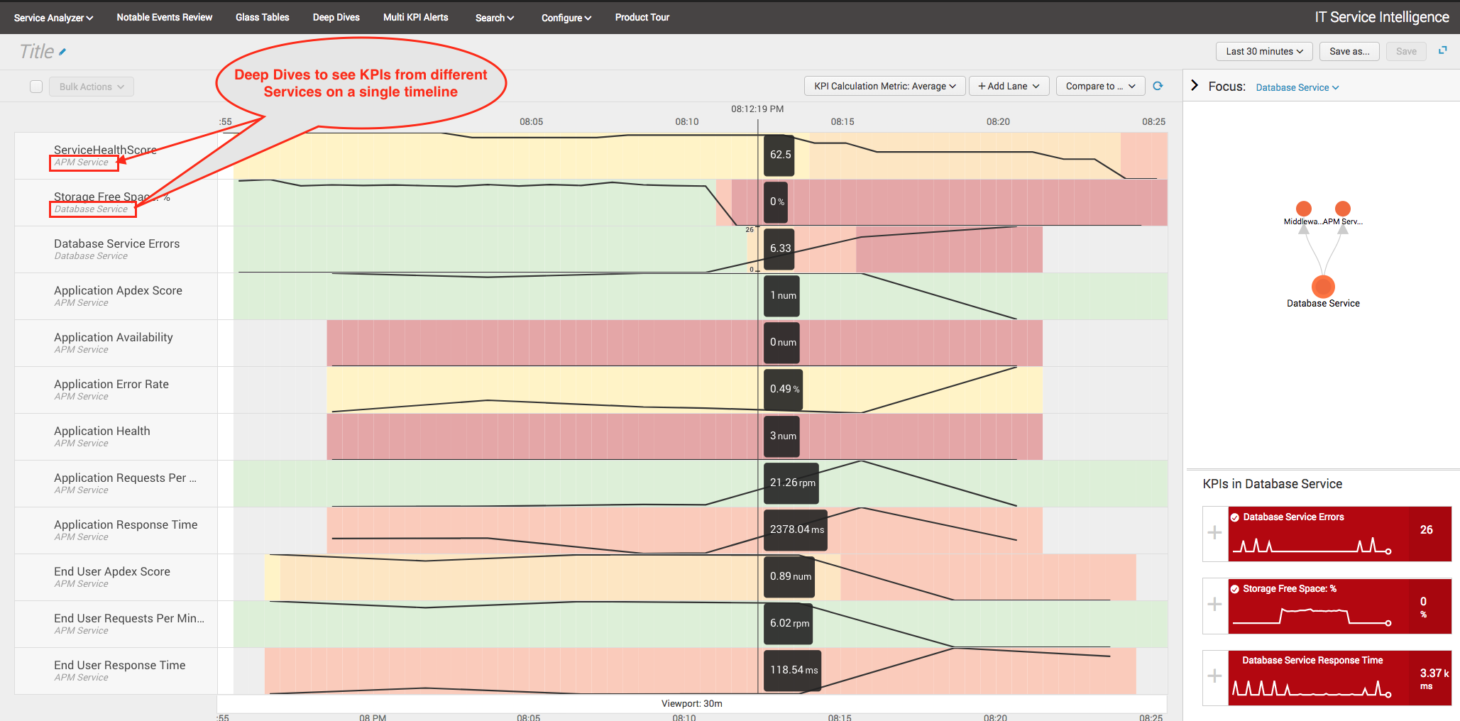

The Service Analyzer page in ITSI provides an overall picture of all your services and the state of their KPIs. From here you can easily drill down into Deep Dives to quickly troubleshoot.

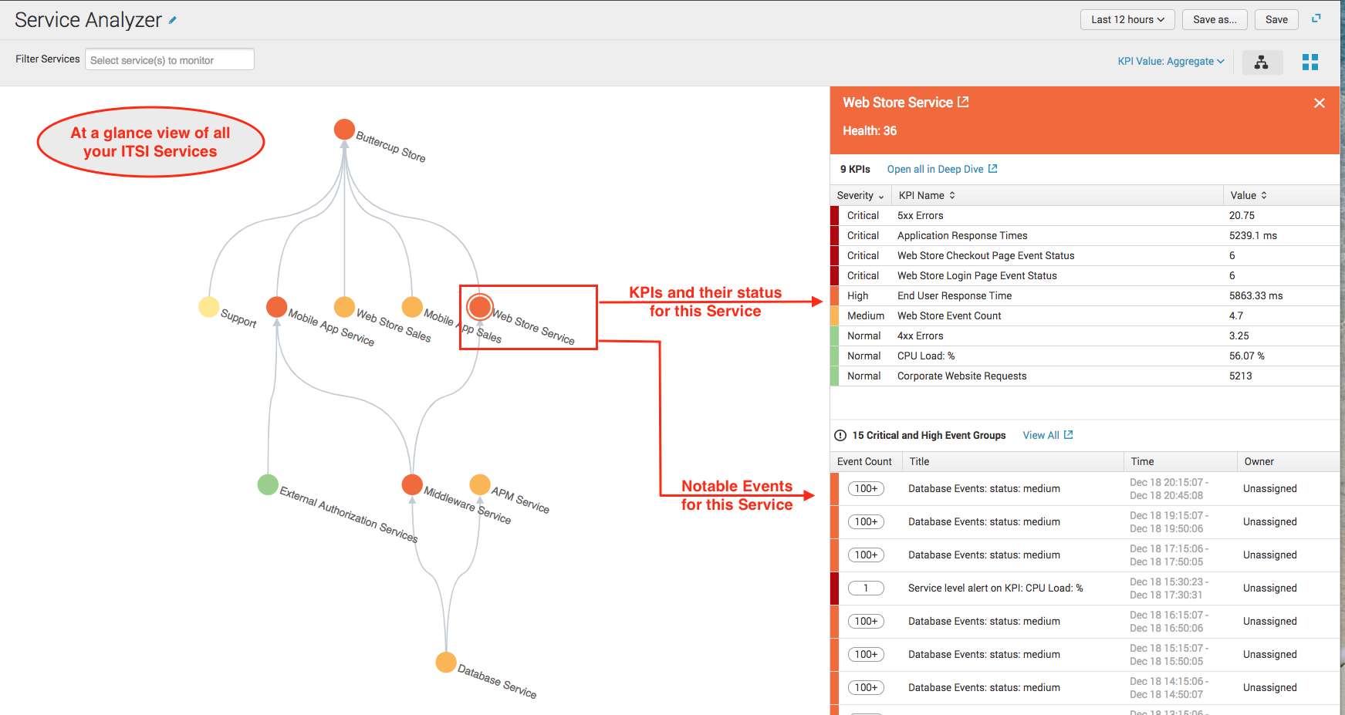

Notable Events provide a way for you to filter the noise and use machine learning to correlate and group similar incidents/alerts. You can use this to quickly identify which KPIs are involved and which Services could be potentially affected downstream or upstream.

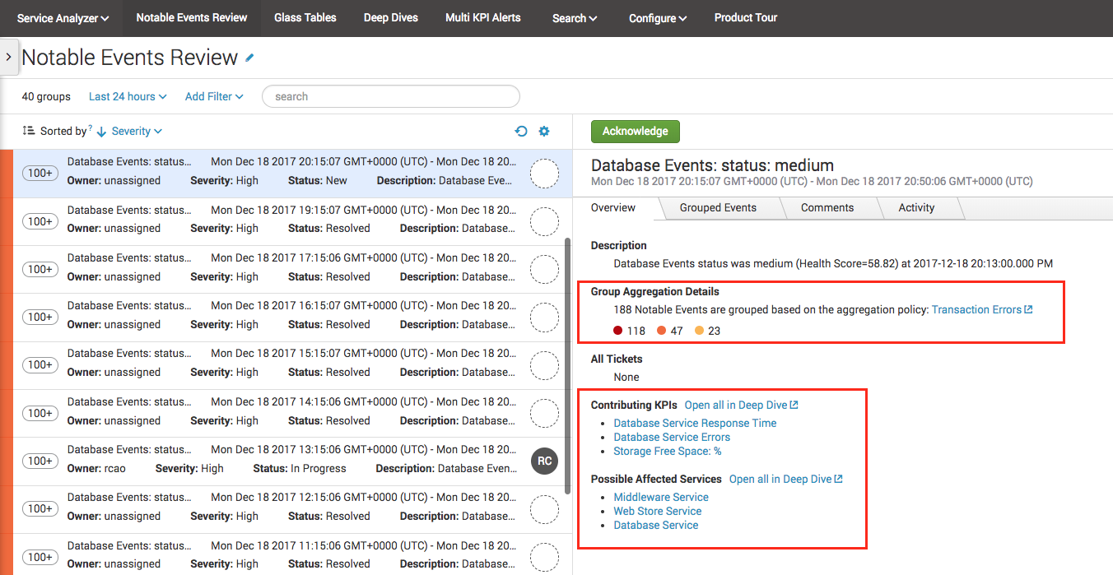

Looking at the grouping tab, you can easily see patterns within the notable events that may help to quickly isolate trouble spots and lead to reduced MTTR.

